Rockbridge International Seminary
Building Healthy Leaders, Who Build Healthy Churches
Cover Story: Education Insider

WINNER OF THE TOP ONLINE
SEMINARY
by Education Insider

“Love the Lord your God with all your heart and with all your soul and with all your mind.” This is the first and greatest commandment. And the second is like it: “Love your neighbor as yourself.” (Matthew 2 2 : 37–39)

The Great Commandment is simple in words yet demanding in practice. For those called into ministry, it means long hours, unseen sacrifices, and a relentless devotion to serving both God and people. Alongside the spiritual weight, many also shoulder the practical challenge of pursuing theological training with limited resources.
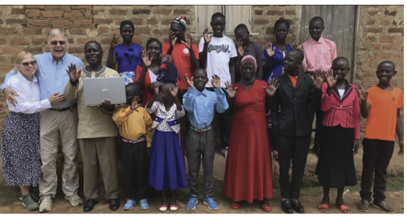
That reality was all too familiar to Pastor Jophiter Obasi of rural Uganda. With no computer and little money, he often received unconventional offerings (even chicken!) as payment for his service from his church. Yet Pastor Jophiter's determination to study theology never wavered. He once walked a full day to reach a post office where he could print the course materials. After sleeping on the ground overnight, he made the long trek back carrying the heavy stack of lessons.

Jophiter Obasi’s perseverance inspired Rockbridge Seminary; an online institution dedicated to equipping servant leaders. They stepped in and provided him with a laptop so that he could continue his calling without interruption. Stories like his embody why Rockbridge International Seminary was founded in 2002.

From the beginning, it was envisioned as a seminary without walls, created entirely online so that training could be accessible to anyone, anywhere. Rooted in the Great Commandment and the Great Commission, Rockbridge equips shepherd-hearted leaders for vocational ministry without requiring them to step away from their families, congregations, or careers. Designed for men and women already serving in ministry, its fully online and accredited model allows students to remain deeply engaged in their callings while receiving high-quality theological education.

The goal is not merely to produce great preachers or effective ministers, but to form healthy pastors and Christian leaders who can lead out of a deep relationship with Jesus, withstand the pressures of ministry, and in turn cultivate healthy churches and ministries that endure.

“Our education model is designed to be accessible, affordable, flexible and Christ-centered training, allowing students worldwide to deepen their knowledge and skills without leaving their local context,” says Tommy Hilliker, president.

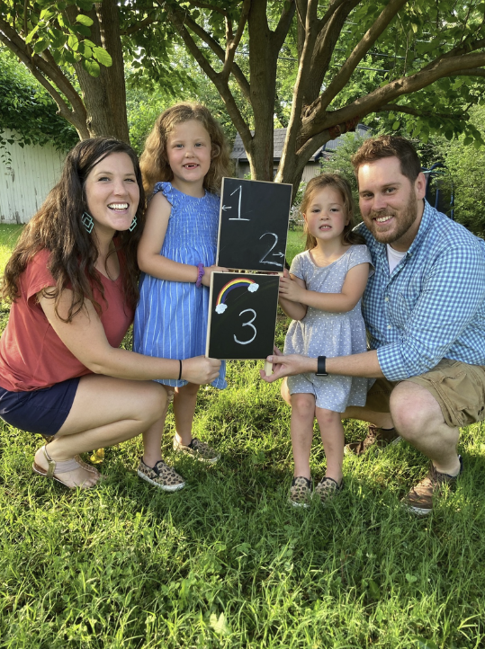
Education Built Around Life and Ministry
Rockbridge’s model is intentionally created for adult learners who juggle church responsibilities, family, and work. Each course runs on an eight-week schedule in a fully asynchronous format, enabling students to study when it fits their personal schedule. Every course is grounded in the Great Commandment and the Great Commission: worship, fellowship, discipleship, ministry, and evangelism. These five purposes shape every discussion, assignment, and application, ensuring that learning is never abstract but always tied to real-world impact. Students write papers, engage in online reflection forums, and practice the lessons learnt within their local ministries, staying rooted in their callings while being formed spiritually, theologically, and missionally.

The classes guide students through the theology of evangelism, helping them apply gospel principles in the unique contexts of their own ministries. They examine the theology of fellowship, exploring what it truly means to be the body of Christ and how divine community differs from ordinary friendship. In the study of discipleship, students learn not only how to nurture spiritual growth in others but also how to build and multiply disciples effectively. Worship is framed as a lifestyle, a posture of communion with God expressed in work, family life, and daily routines.

Alongside these practical and relational themes, students engage with the traditional seminary canon. They study the Old and New Testaments, hermeneutics, biblical interpretation, and ministry practices, all integrated into Rockbridge’s mission to form leaders who are both theologically grounded and practically equipped.


Resilient Leaders, Healthy Churches
Yet beyond textbooks and theory, Rockbridge shapes lives through a framework of four dimensions: head, heart, hands, and habits. The head represents knowledge of God, Scripture, and theology. The hands focus on practical ministry skills. The heart emphasizes posture and health, since healthy leaders form healthy churches. The habits involve spiritual disciplines that sustain faith long-term. Every course includes a spiritual journey component in which students practice disciplines like journaling, prayer, fasting from food, social media, or technology, habits that keep leaders anchored in Christ.

This emphasis arises from a conviction that many Christians in the West settle for what Hilliker calls ‘fast-food spirituality’: quick prayers, brief devotionals, and hurried moments with God. These may help temporarily, but cannot form the resilience needed for long-term faith and perseverance. Rockbridge instead encourages what it describes as ‘fine-dining spirituality’, like a family meal that requires preparation, time, and intention. This deeper, unhurried communion with God leads to lasting transformation.

Our education model is designed to be accessible, affordable, flexible and Christ-centered training, allowing students worldwide to deepen their knowledge and skills without leaving their local context.
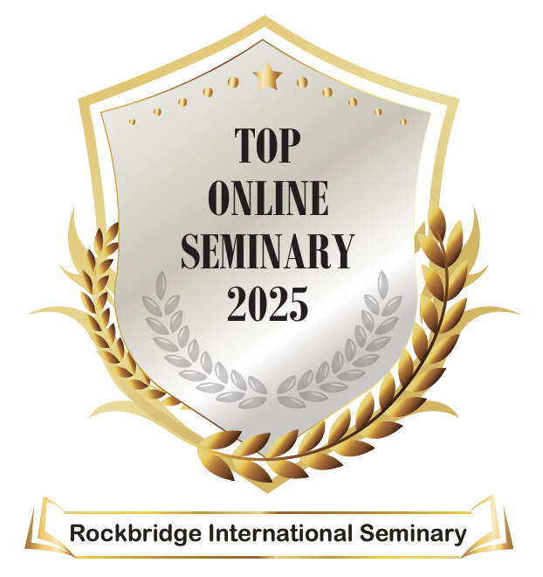
Taken together, Rockbridge’s approach equips students with theological knowledge, practical ministry skills, and the resilience (emotional, mental, physical, and spiritual) needed for a lifetime of leadership. In fact, this seminary teaches the Ephesians 4 model of leadership, where pastors are equippers of the saints, empowering the congregation to do ministry work.

“The goal is not merely to produce great preachers or effective ministers, but to form healthy pastors and Christian leaders who can lead out of a deep relationship with Jesus, withstand the pressures of ministry, and in turn cultivate healthy churches and ministries that endure,” Hilliker explains.

His vision comes alive in the way Rockbridge walks alongside its students, creating a supportive environment where leaders are trained and encouraged.

A Seminary That Feels Like Family
For many students, the most surprising discovery is how immediately applicable the learning becomes. As one student reflected, “I had no idea I could take what I learned in class on Monday and apply it in ministry by Sunday.” The connection between coursework and real-world leadership, whether in a sermon or a staff meeting, makes the education both practical and transformative.

Rockbridge also understands that every student carries heavy worldly burdens while fighting spiritual warfare in their ministry life. They may even face crises such as cancer, the loss of a spouse, or the death of a child. In these moments, Rockbridge extends beyond academics to become a family. For instance, one student continued his coursework while caring for a spouse with terminal cancer. Supported by faculty and peers through the long nights of caregiving, through grief, and ultimately to graduation, he later said simply, “I could not have made it without Rockbridge’s support.”

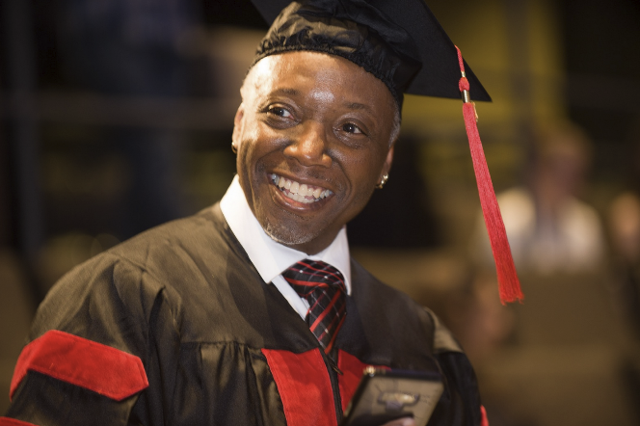
This level of care is built into the seminary’s ethos. Faculty and staff know students by name, walk with them through hardship, and celebrate their joyful moments. Flexibility is built into the model. During the COVID-19 pandemic, when some students lost ministry positions, Rockbridge urged them to pause their degrees until they were ready to return. Some did not resume for years, but when they did, Rockbridge was still there—welcoming, encouraging, and helping them find their next place of service, irrespective of borders.

Reaching the Nations with Gospel Leaders
Today, that family extends across continents. Beyond North America, Africa is now becoming the epicenter of global church growth, with Latin America following close behind. Rockbridge already serves pastors and leaders in Uganda, Nigeria, across Africa, and in South America, many of whom lead vibrant but resource-poor congregations. Rockbridge’s passion is to walk with these pastors, equipping them with biblical knowledge and practical skills to strengthen their communities.

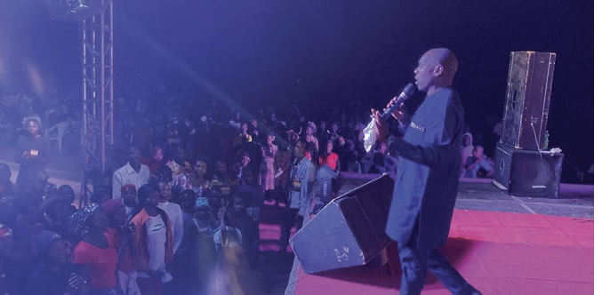
In Nigeria, Pastor Jerry Dadi has devoted his life to evangelism, boldly entering regions where sharing the gospel is not only difficult but dangerous. Alongside preaching, he also meets physical needs through medical missions, establishing small clinics that serve villages otherwise left without care. His ministry reflects both courage and compassion, and Rockbridge is walking with him by providing the theological training and scholarship support he needs to continue multiplying his impact.

From Ghana, Pastor Joseph Ntsiabah, senior pastor of King of Peace Chapel, joined Rockbridge as one of its newer students. Leading a growing congregation, he sought deeper theological grounding and ministry training to shepherd his church more effectively. Rockbridge is equipping him with tools to build disciples, strengthen his fellowship, and expand the reach of his ministry.

These stories reflect Rockbridge’s mission to walk alongside faithful leaders in under deserved regions, equipping them to sustain their calling and transform communities with the gospel globally and locally.

A Vision for the Future
Looking forward, Rockbridge is committed to expanding scholarships, partnerships, and innovative learning platforms that remove barriers for those called to ministry. The seminary always seeks to make learning more interactive, more global, and more community-driven, continually asking how more leaders can be equipped in places where the church is growing fastest and needs are greatest.

With this goal in sight, Rockbridge leaders faithfully serve in every corner of the globe, equipped, encouraged, and empowered to change lives for Christ. They partner with like minded supporters to break down financial and geographical barriers, ensuring pastors everywhere have the training they need for the work God has called them to do. -

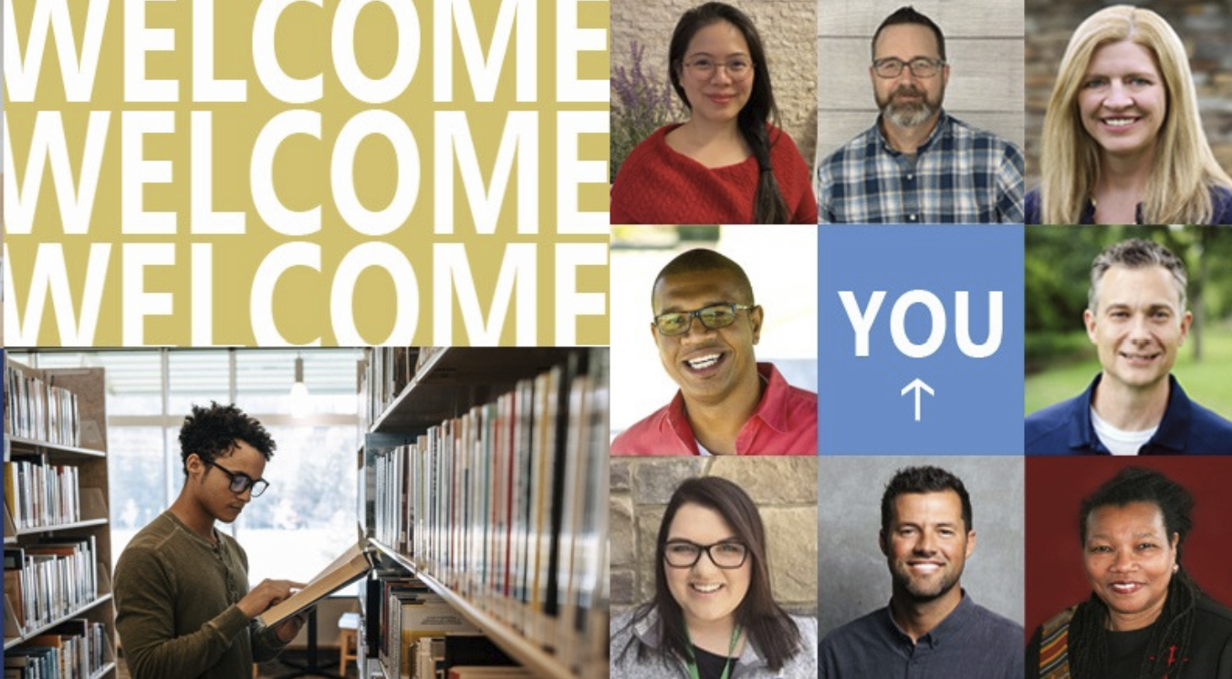


www.Rockbridge.edu

